**Problem Statement :**

Execute Session 16 - Assignment 1 (Machine and Sensor data analysis) using Reduce side join and compare which join is faster in normal conditions.

Solution:

Driver Class:

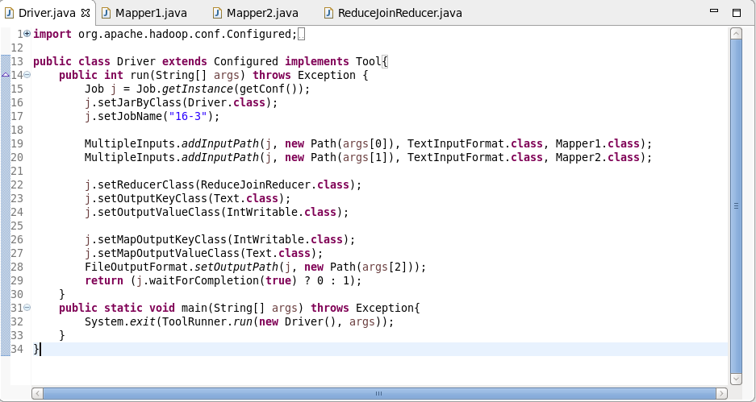

Mapper Class 1:

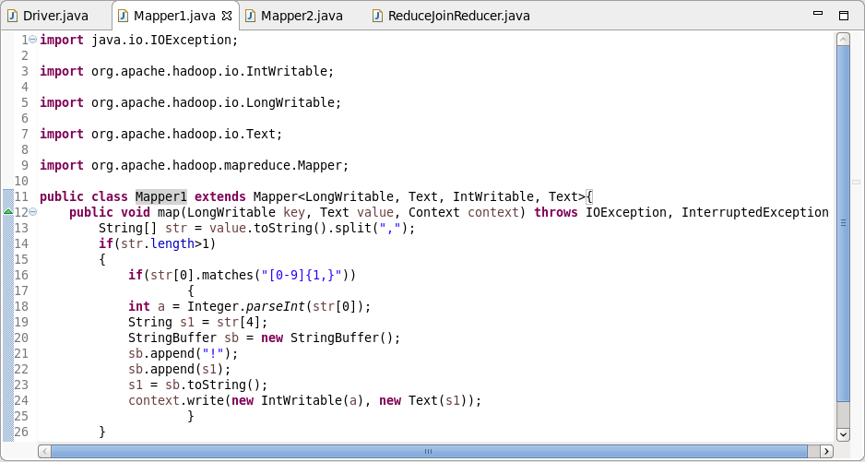

Mapper Class 2:

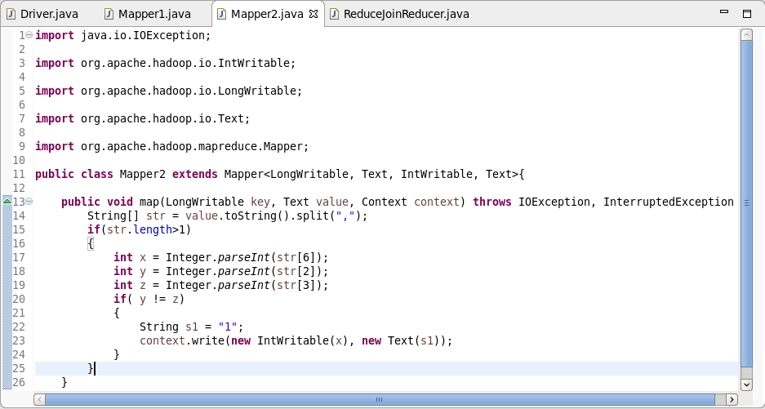

Reducer Class:

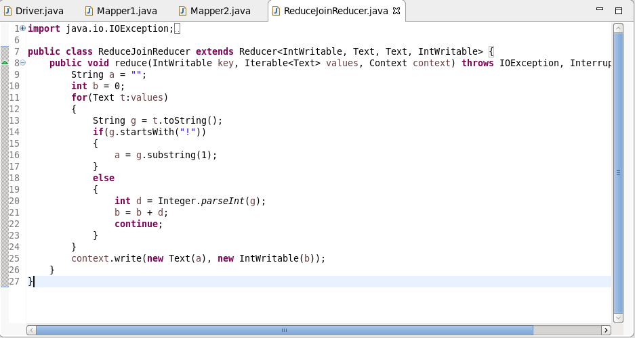

Execution Command:

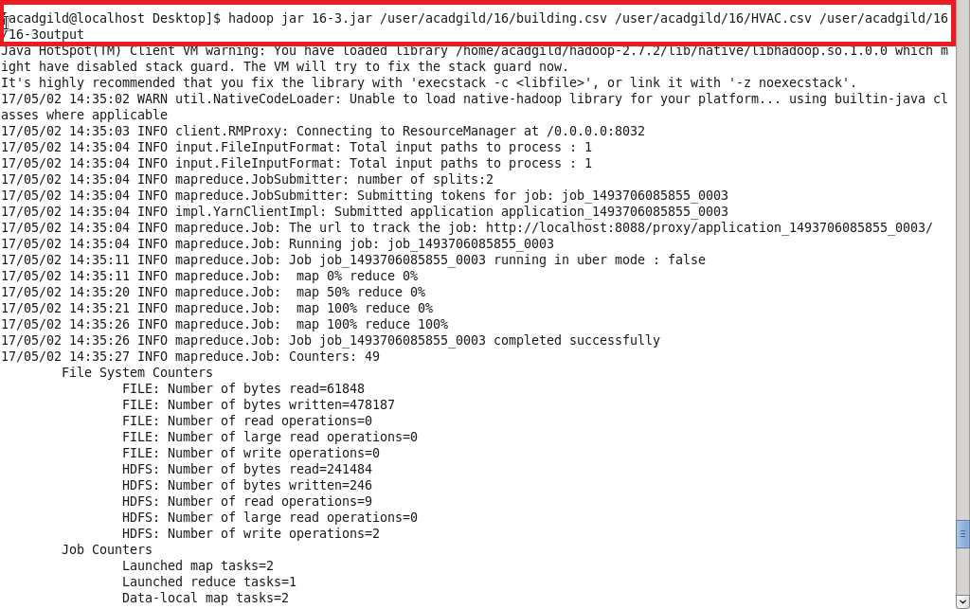

Output:

